

**UNIVERSITY OF PETROLEUM AND ENERGY STUDIES**

**School of Computer** **Science**

**2020-21**

**GRAPHICS AND ANIMATION TOOLS LAB**

**Faculty: Dr. DURGANSH SHARMA**

**Assistant Professor**

**Department of Cybernetics.**

**School of Computer Science, UPES**

**Submitted By:**

**Name- Ishita J Karmakar**

**Roll no-R100217107**

**Batch-B3**

**Semester- 7**

**Course-B.Tech CSE-OSOS**

**SAP ID- 500064067**

**EXPERIMENT NO 10**

**Aim** :- Design a 3D Building using Blender.

**Objective** :- To Design a 3D Building using features of Blender 2.8.

**STEPS TO DESIGN A 3D BUILDING-**

1. Open Blender workspace select the existing cube and go to edit mode.
2. Add loop cuts to the cube, as per the size of glass you want to put in the front face of your building.
3. For the frames of the glass, use extrude region. Perform the similar step for the backside of the building.
4. For the window, add a cube, resize it along the various axis as per the need, and then add loop cuts in order to make window frames.
5. Duplicate the layers of building, to make a 6 storied building.
6. For the top of the building extrude and scale the last face and the add a sphere at the top to make it look more attractive.

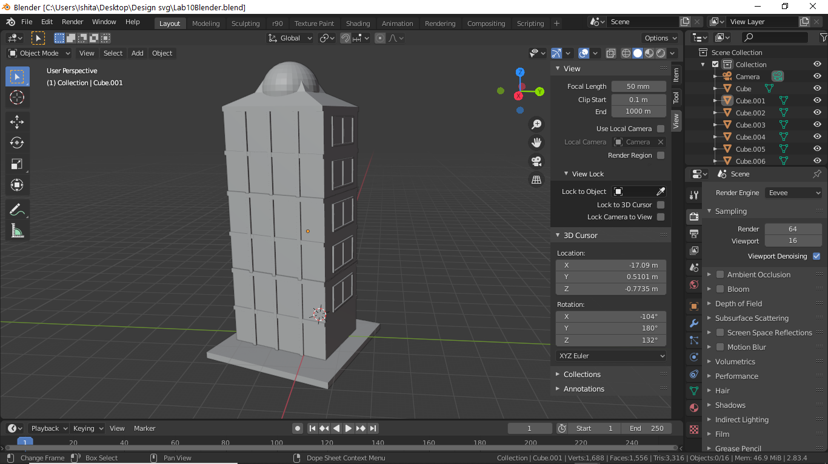

1. At last add textures to the building, windows, glasses and the window frames.
2. Add an environment texture, to make the the look more realistic.

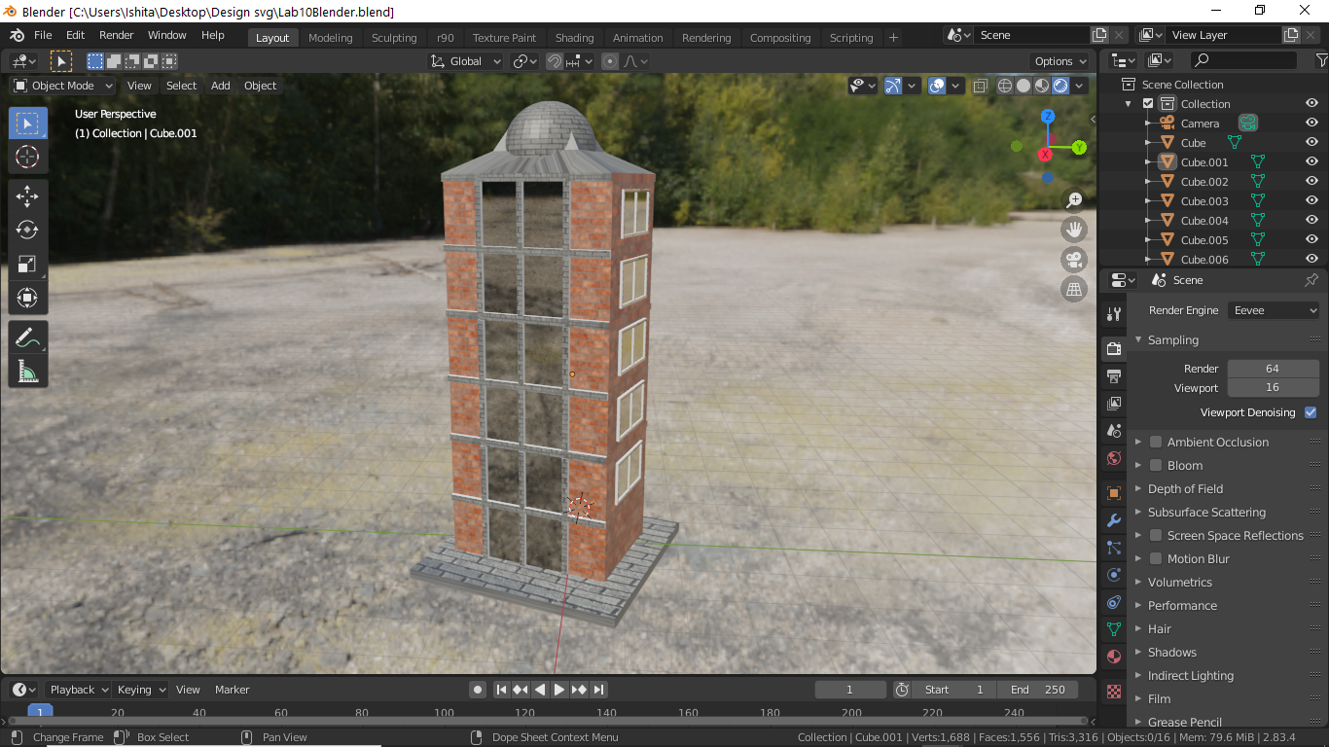

1. Now render the final model.

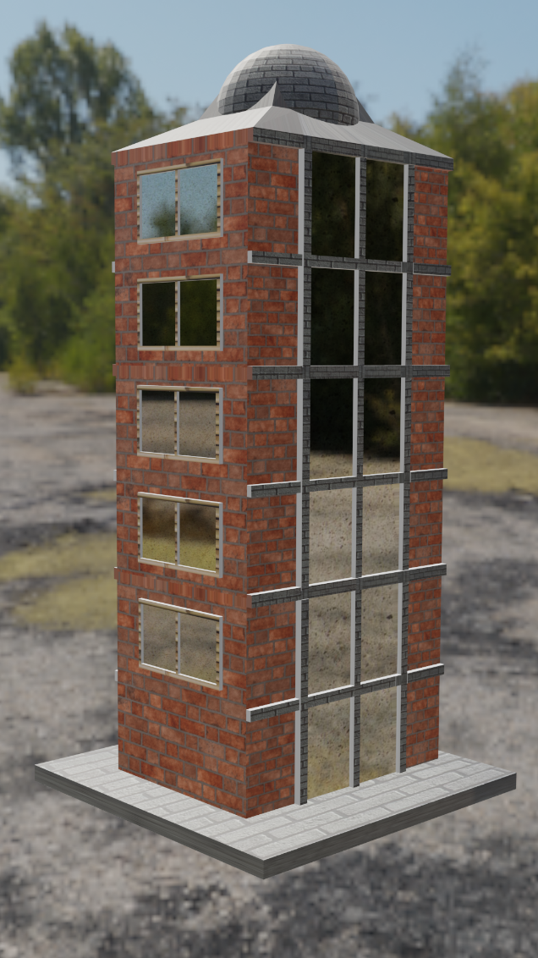

Link for Google Drive: -<https://drive.google.com/drive/folders/1LfsT6U1FV5ac3cZcT6tqhaBmVYEE10gX?usp=sharing>